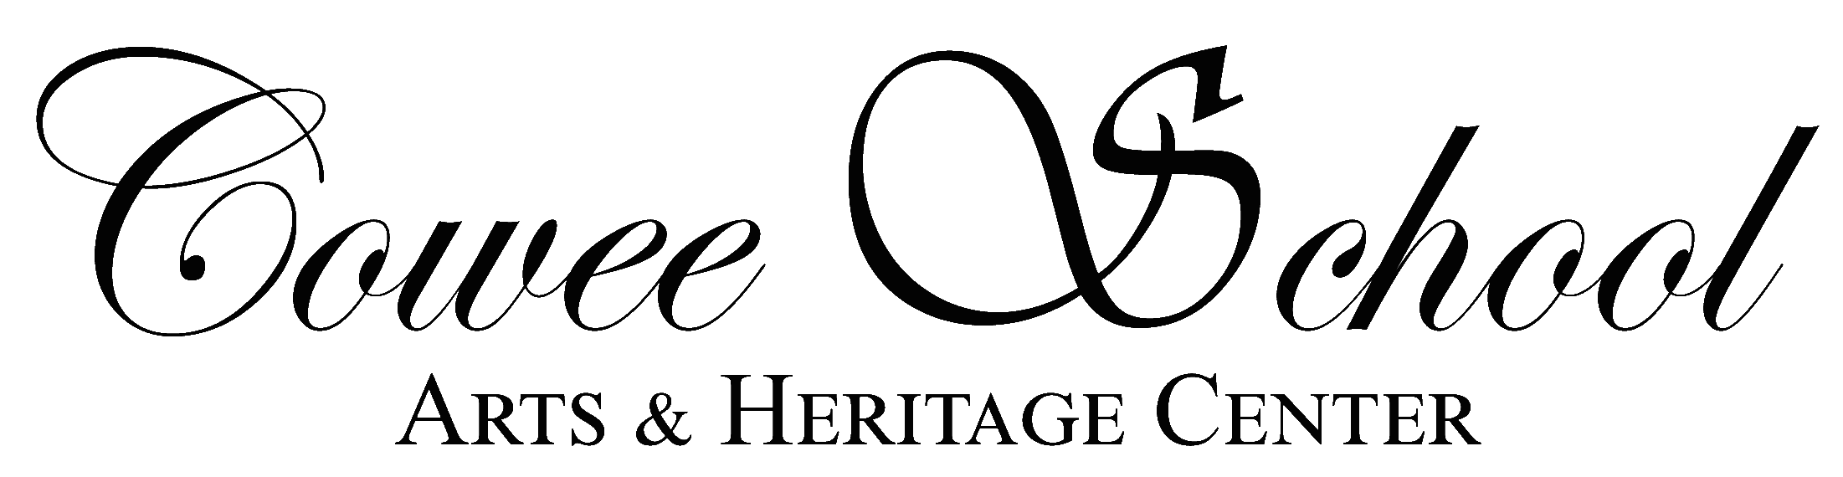

Rules of the Cowee School Farmers Market

1. Sellers must reside, be a resident of Macon County and produce the items they sell within Macon and surrounding counties. Any other vendors/sellers must be approved.

2. Sellers must be the original producer, (or a family member or an employee) of all items being sold. No buying and reselling of produce or other products is allowed.

3. Sellers must submit a Vendor Application prior to any sales. There will be no annual fee for the 2022 market season. Donations to Cowee School are appreciated.

4. The market will operate from 3:00p.m. until 6:00p.m. each Wednesday, May through October. Arrive early enough to set up. Spaces are first come 1st choice; no spaces are permanent.

5. Products which can be sold include:

a. Any vegetable grown by the seller from seeds, sets, or seedlings.

b. Any fruits, nuts, or berries grown by the seller from trees, bushes, or vines on the sellers farm.

c. Any plant grown by the seller from seed, seedling, transplant, or cutting.

d. Bulbs and seeds propagated by the seller.

e. Eggs produced by the seller's poultry.

f. Mushrooms grown by the seller.

g. Honey produced by the seller's bees.

h. Preserves, pickles, relishes, jams, and jellies produced by the seller. There is a pickle school online: Vendors who preserve are required to be certified on low acid foods in order to sell at the market*

* Contact one of NCDA’s compliance officers at 919 733 7366 or visit their website: https://www.ncagr.gov/fooddrug/food/homebiz.htm to learn more on how to certify your kitchen.

i. Baked goods by the seller. All baked goods MUST be covered/packaged.

j. No “low-acid” canned foods such as green beans, corn, peas, carrots, etc. may be sold.

k. Wild fruits harvested by the seller in Macon and surrounding counties

6. Vendors are allotted one space.

7. Other Sales: Cowee School must approve specific requests.

8. No Crafts Allowed. There will be a separate market for Crafts.

9. All food must meet state and local food regulations. All produce must be of top quality. Certified kitchens are required.

10. Contacting NCDOR for any “Value-Added” products listed for applicable sales tax is each vendor’s responsibility and it’s the law. They will provide you with a NCDOR (NC-BR) number.

11. Each seller is responsible for cleaning up the area around his/her vehicle.

12. No solicitation by individuals or group. Re: Politics, Religious groups, etc., during market hours.

13. Sellers should not move their vehicles in or out of the market area during times when such
movement would pose a danger to people in the shopping area.

The by-laws of the Cowee School Farmer’s Market are intended to protect and produce a friendly and safe market for everyone. Vendors violating the by-laws are subject to suspension of their privilege to sell at the market.

A COA certificate of analysis and a State License to grow industrial hemp/CBD is required to sell such products at the Market.

